Xena Data Traffic Statistics (known as “Xena One Second Data” by the FENS team)

Xena Histogram

PepWave LTE router Cellular Quality from PepWave Cloud Management system

PRTG SNMP reports

Comcast, Cox, or other cable modem statistics

iDirect Modem statistics (VSAT)

Iridium Modem statistics

Ixia ixChariot Data Traffic Statistics (known as “Ixia Two Second Data” by FENS team)

Others

Xena Data Traffic (**xena**)

Timestamp,SrcPort,SID,DestPort,TID,TxL1Bps,TxBps,TxFps,TxBytes,TxFrames,RxL1Bps,RxBps,RxFps,RxBytes,RxFrames,RxFcsErrors,RxSeqErr,RxPckLossRatio,RxMisErr,RxPl

Ixia ixchariot (**ix_chariot**)  Note: These are all the same except for first few columns. It will need null values injected for missing data prior to upload

timestamp,                                                    Source IP,Destination IP,Throughput,Avg Throughput,Min Throughput,Max Throughput,Total Measured Time,Total Bytes Sent,Total By

timestamp,application,                              Source IP,Destination IP,Throughput,Avg Throughput,Min Throughput,Max Throughput,Total Measured Time,Total Bytes Sent,Total By

timestamp,mix,                                            Source IP,Destination IP,Throughput,Avg Throughput,Min Throughput,Max Throughput,Total Measured Time,Total Bytes Sent,Total By

timestamp,mix,application,                      Source IP,Destination IP,Throughput,Avg Throughput,Min Throughput,Max Throughput,Total Measured Time,Total Bytes Sent,Total By

timestamp,mix,application,user,              Source IP,Destination IP,Throughput,Avg Throughput,Min Throughput,Max Throughput,Total Measured Time,Total Bytes Sent,Total By

IXia ixchariot User Info (**ix_chariot_user**)

timestamp,User,Mix,Application,Direction,Source Endpoint Name,Destination Endpoint Name,Source Endpoint Location,Destination Endpoint Location,Source Endpoint

Pepwave wan_quality (**wan_quality**)

WAN name        Type      Cell ID   Carrier  Band     LTE - RSRP          LTE - SINR              LTE - RSRQ          Latency MNC     MCC      Time     Latitude              Longitude           Altitude

Xena Histogram (**xena_jitter_hist**)  Note: Data would need to be converted into 2 columns start, packets prior to upload

RX Jitter Distribution (ns) (Histogram)

X (start):,-1,0,1048576,2097152,3145728,4194304,5242880,6291456,7340032,8388608,94

Y (packets):,0,115836,49635,15214,8689,8140,14373,34530,163212,11904,4683,2815,245

Xena Histogram (**xena_latency_hist**)  Note: data would need to be converted into 2 columns start, packets

RX Latency Distribution (ns)

X (start):,-1,0,2097152,4194304,6291456,8388608,10485760,125829

Y (packets):,0,0,0,0,0,0,0,0,0,0,10,908,2833,3351,12855,63229,8

**Data File Sources:**

* **Xena Data Traffic Statistics (known as “Xena One Second Data” by the FENS team)**
* **Xena Histogram**
* **PepWave LTE router Cellular Quality from PepWave Cloud Management system**
* **PRTG SNMP reports**
* **Comcast, Cox, or other cable modem statistics**
* **iDirect Modem statistics (VSAT)**
* **Iridium Modem statistics**
* **Ixia ixChariot Data Traffic Statistics (known as “Ixia Two Second Data” by FENS team)**
* **Others**

Attached are copies of files representing some of the data sources I have mentioned in the above table.  I have identified the specific files below.  We can setup another meeting to discuss format and layout of the data files, as well as how best to process them.

**Xena Data Traffic Statistics**

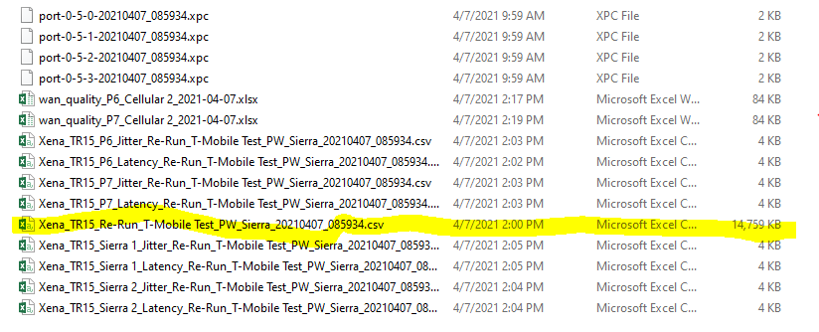

**Xena Histogram**

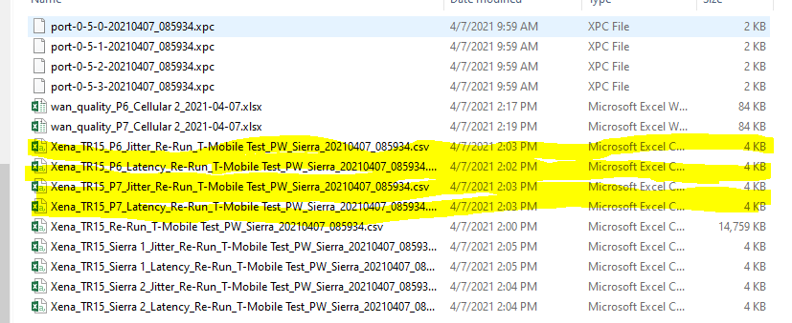

**PepWave LTE router Cellular Quality from PepWave Cloud Management system**

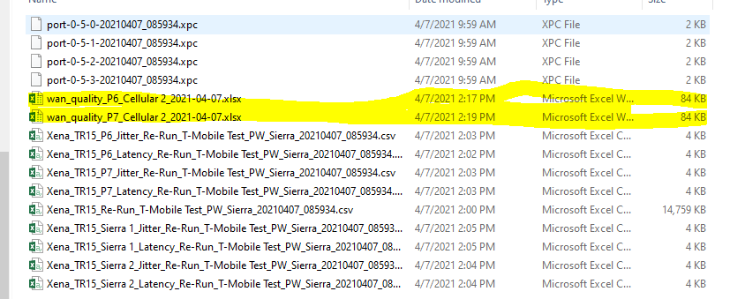

**Ixia ixChariot Data Traffic Statistics**

**(See attached “ixchariot.csv”)**